I need some Wiggle Relief!!!!!!!

If your Rear View Mirror is Wiggling, this post may be for you. I have found out unfortunately through personal experience and while helping out fellow-Corvette owners ~ in the majority of C6 cases, the Rear View Mirror “Wiggle” problem is not the Rear View Mirror!!! If you have about an hour (or longer, take your time…no need to rush), I have an easy ~ much less expensive DIY fix you may want to try before shelling out the big bucks for a new Rear View Mirror Unit (mirror, bracket, etc). Believe it or not, in viewing member’s posts and in discussions with my fellow Corvette brethren over past couple of years, in the majority of cases; My Rear View Mirror wiggles or my Mirror is lose ~ they indicate the problem didn’t surface until after the dreaded “stone-chip” or “cracked” windshield replacement initiation we all seem to face sooner…if not later. In actuality, I have found in 99% of the cases I’ve been involved with, the culprit is this little, poorly designed thing called the Cam-Lock ~ which as shown below; is a 2-part unit that attaches to the Mounting Bracket and the Windshield. Basically, the Cam-Lock acts as the device for attaching the Mounting Bracket w/Rear View Mirror, to the windshield.

In the 1st photo (topical view), you are actually looking at what we will refer to has Part “A” of the Cam-Lock device, which is attached to the base of the Mounting Bracket w/Rear View Mirror still attached. In the 2nd photo, you are looking at what we will refer to has Part “B” of the Cam-Lock device, which is still attached to the windshield. The rotary looking opening in Part “A” (1st photo), surrounded by the Torx screws interfaces/attaches to Part “B” (2nd photo).

FYI ~ don’t be overly concerned about the 3-tiny raised metal-points that run counter to the Torx screws. They don’t actually hold the Cam-Lock on, but they will wear-down…if the Mounting Bracket is removed/reinstalled too often and could end-up being the source of some degree of looseness, but unless you have taken this mirror off several times, shouldn’t be an issue.
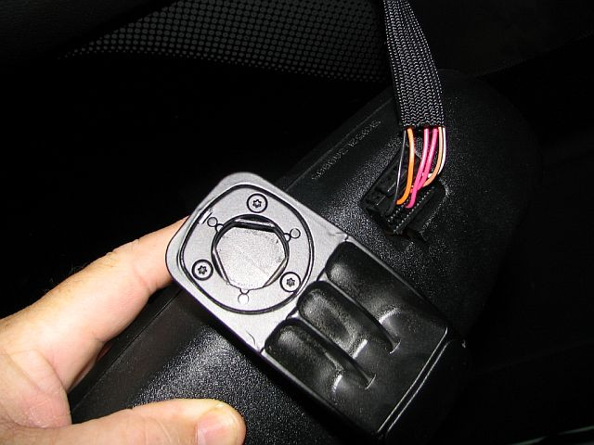
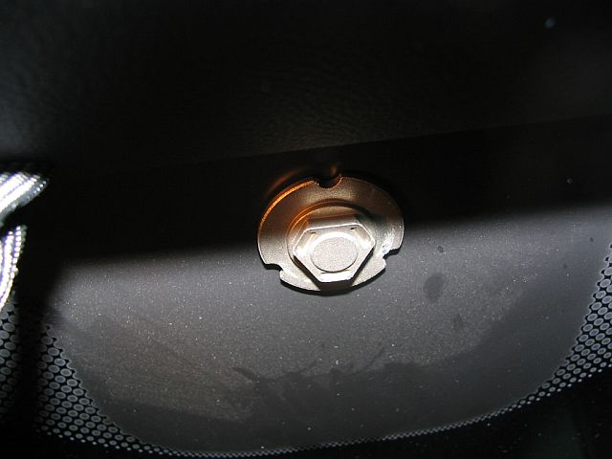

Mounting Bracket/Rear View Mirror Unit Removal: The “unit” will detach from the windshield as one complete unit (mirror w/bracket). Yes, with a little effort, you can detach the Rear View Mirror from the Mounting Bracket ~ but for this minor repair, there is no need to separate the mirror from the mounting bracket – so don’t!

MAKE SURE YOU HAVE DISCONNECTED YOUR POWER CORD AT THE REAR OF THE MIRROR BEFORE ATTEMPTING THIS STEP! Swivel the mirror as if you were adjusting it…about 1/4 to 1/3 turn. Then turn the Mounting Bracket (a counter-clock wise twist) and the whole unit will detach from the windshield.

Okay, in order to fix the “wiggle” problem ~ or repair the Cam-Lock, you first have to remove the 3-Torx screws to expose the source of the problem.

Take a #8 Torx Driver and unscrew the 3-Torx screws. When you pull-off the face-plate of the Cam-Lock, it will expose 3-pins ~ if the pins fall out when you are removing the face-plate – no worries, but keep them handy because you are going to reuse them. If I’m right, you are about to discover the source of your “wiggle” problem. Examine the pins…if you notice that any of the 3-pins are bent, then you have identified the gremlin! Ah yes, the problem ~ this poorly designed Cam-Lock relies on these pin being perfectly straight and aligned in there respective bays (easy to see how they lay or align into cut-outs or slots in the base of the Cam-Lock casting) in order for the Cam-Lock to function properly.

Take a pair (2) of pliers…or whatever you are comfortable working with, because in order to correct the problem, you need to straighten the pins. Once they are straight, you are ready to reassemble. Dab a little Vaseline (whatever) on the ends of the pins ~ only to help hold them in place while you reassemble the Cam-Lock disk. Reassemble; pin, disk, Torx screws…once you have the Cam-Lock reassembled, you are ready to reinstall the Rear View Mirror Unit (including mounting bracket) onto the windshield.

Mounting Bracket/Rear View Mirror Unit Installation: To reinstall the unit, keep the mirror at that setting/angle at the time of removal; then line-up the Mounting Bracket/Cam-Lock (Part “A”) with the Cam-Lock (Part “B”), located on the windshield at about a 90 degree angle; then turn the Mounting Bracket w/Rear View Mirror attached (clock-wise twist). Done…the whole Rear View Mirror Unit should be reattached to the windshield! Okay, your almost there; just 3 more steps ~ Connect your Rear View Mirror Power Cord, adjust your personal Rear View Mirror setting, take her for a test ride and HOPEFULLY, no more wiggles!

