Tutorial on Refinishing a Glass Targa Top

Found on: http://www.101corvetteprojects.com/2009/11/27/refinish-the-corvette-c5-coupe-targa-top/

How to refinish your Corvette C5 Targa Top....
I bought a used clear targa top and wanted to restore it to new condition for use on my Corvette C5 Coupe. This is what it looked like when I got it:
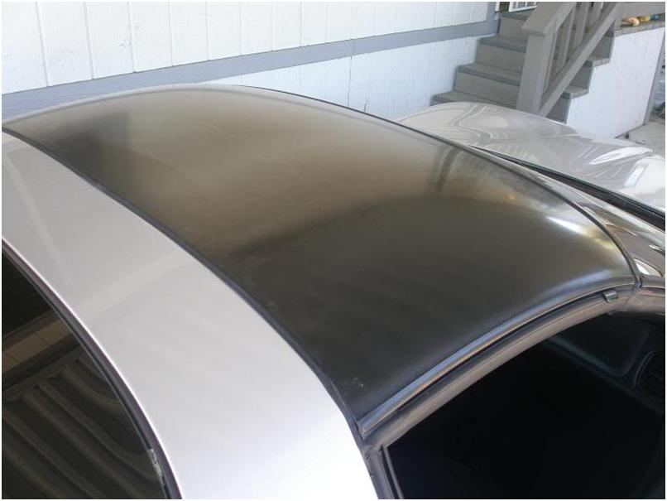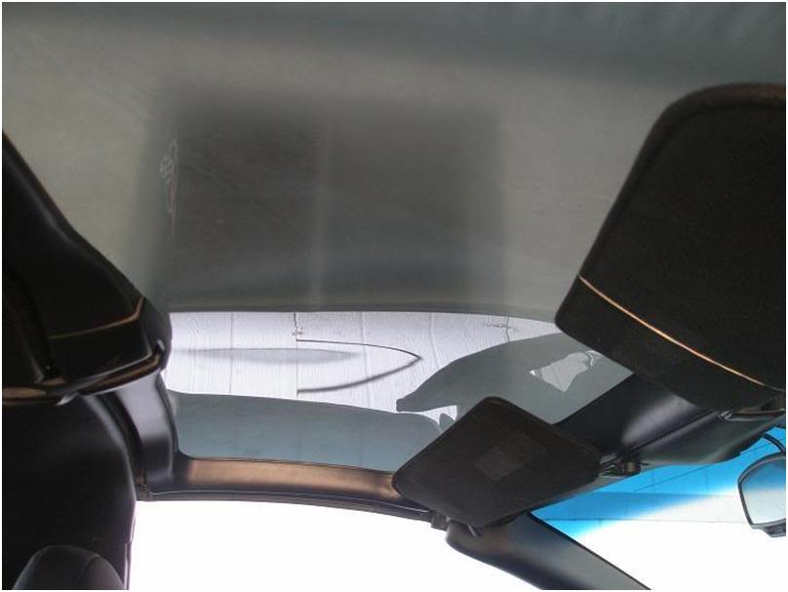
All you need to refurbish the top is:
1000 grit wetsand paper
1500 grit wetsand paper
2000 grit wetsand paper
Rubber sanding block
Squirt bottle
Dish soap
Shammy
Terry towels
Porter Cable Polisher
Maguire's medium cut, fine cut, and swirl remover
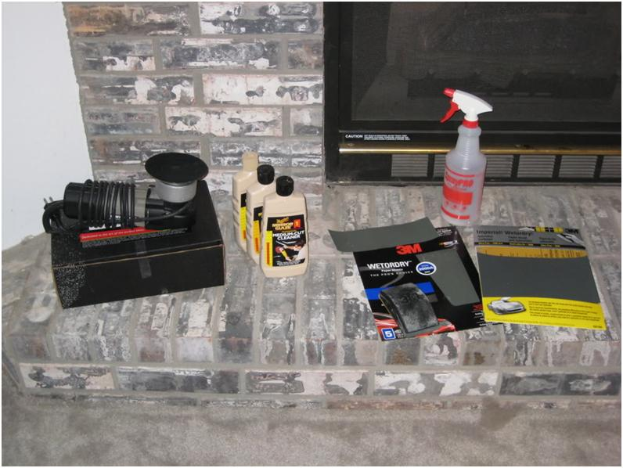
First thing I did was to remove all of the old clear coat and the oxidized plastic from the top. I just used 1000 grit and wet sanded it down. This took about three hours to accomplish. It was easy to tell if I was finished because you can look at a light through it and see where it was fully sanded or not. A tip for wet sanding. I used an old shammy to continually clean the surface I was sanding. This makes it easy to remove all of the material from sanding and it the surface will quickly dry so you can tell what areas need more attention.
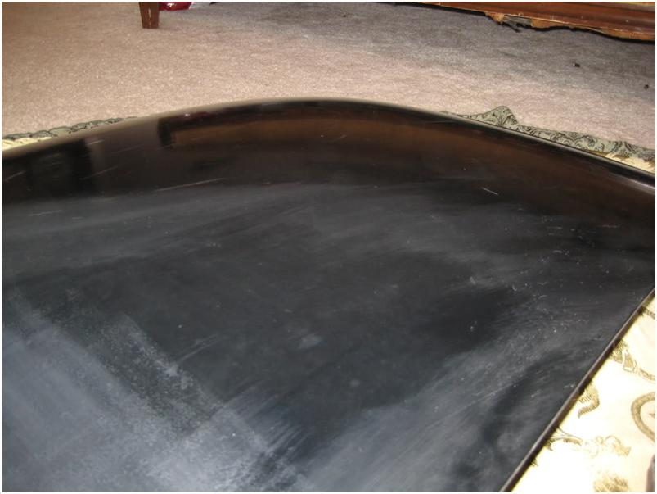
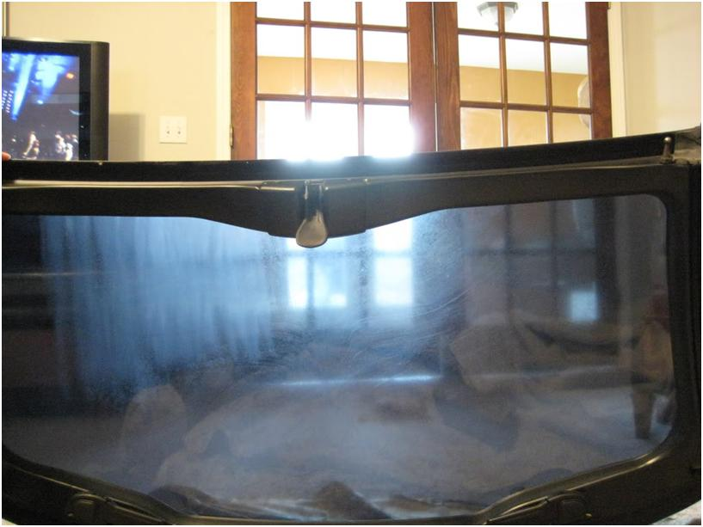
There are two ways to finish the top from here. At this point it is ready for paint or clear coat. I sprayed a thick layer of PPG clear coat that I had laying around on it. This gives the acrylic UV protection and gives more material to polish out. It is recommended that the surface be sanded down with 600 grit, but I just kept it at 1000 because I was scared of using that course of paper on the top. The coat has stuck fine so far.
(EDIT: I got some requests for the type of PPG Clear that I used. It is Deltron High Velocity Clearcoat. DC3000)
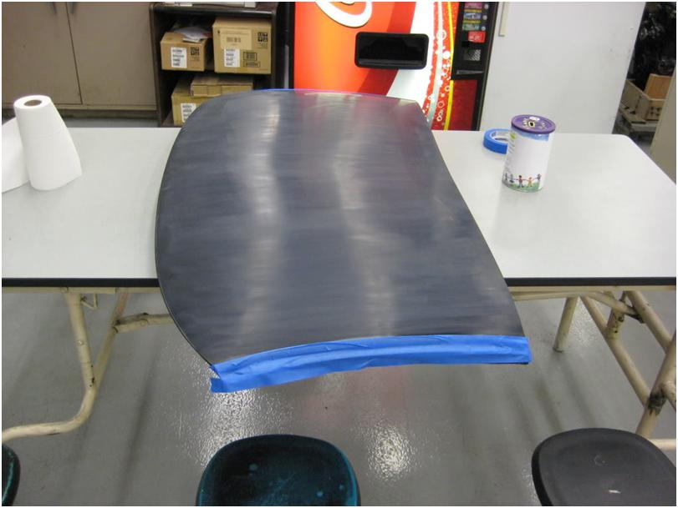
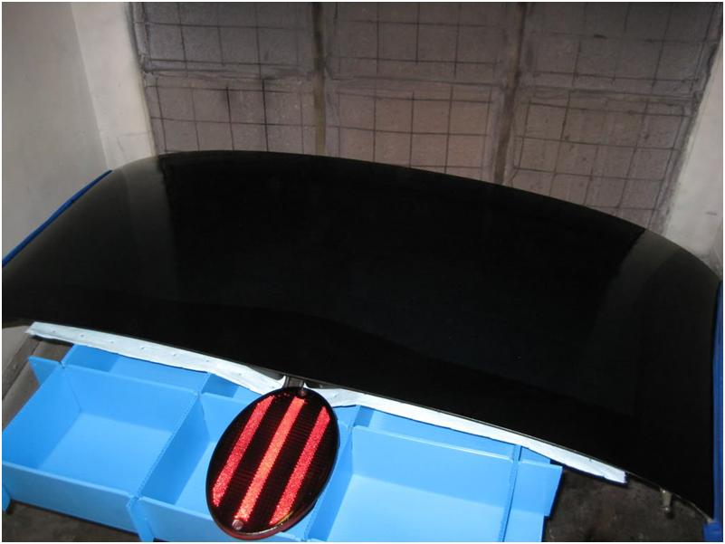
I am not the best with a paint gun so the finish had an orange peel effect to it. I wet sanded the top again, this time with 2000 grit paper in preparation for polishing it. Looking back I should have started with 1500 grit and then worked my way up to 2000, but again, I like to start with a finer paper and just do extra work so I take off as little material as possible. When sanding for polish, always sand in one direction, then when you step up to the next grit, sand 90degrees to the previous grit. Keep sanding till you can't see the marks from the previous grit. The following picture is where I started sanding the top after paint and you can easily see the orange peel.
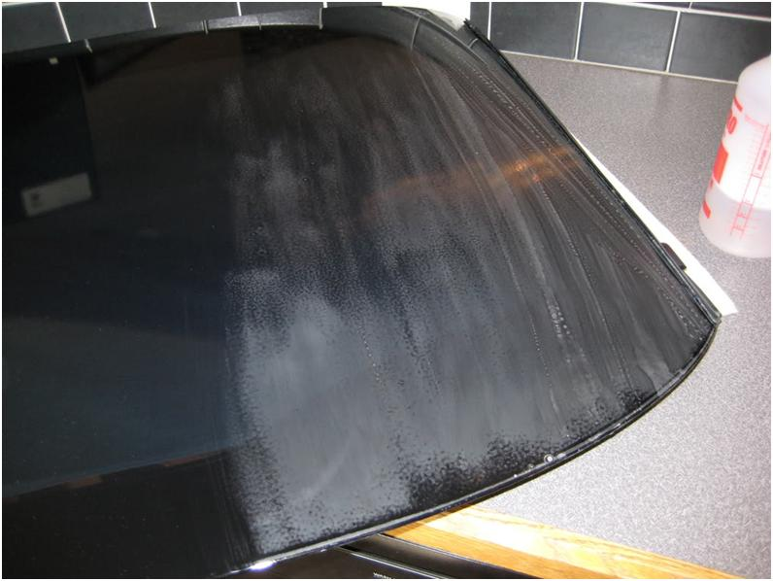
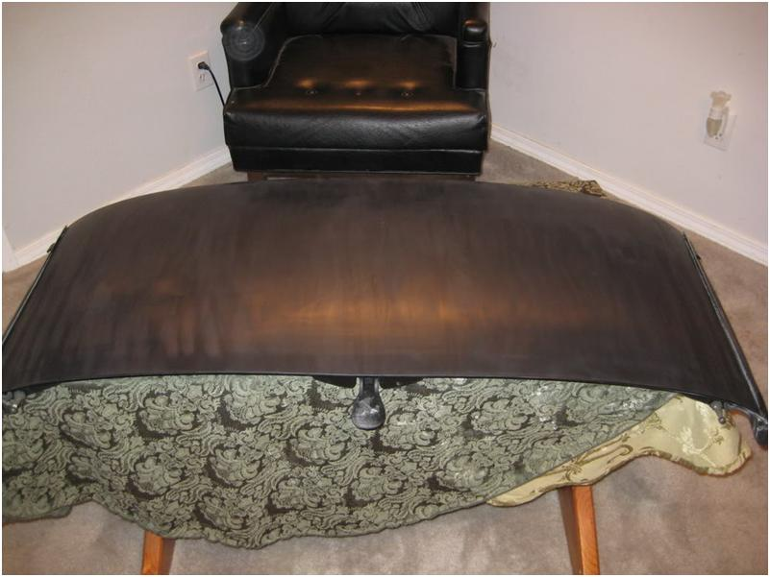
When you get the whole thing sanded out, you are ready for polish. I used a PC 7424 to polish it out, but any polisher will do. I started with the medium cut cleaner and worked it till all of the sanding marks were removed from the finish.
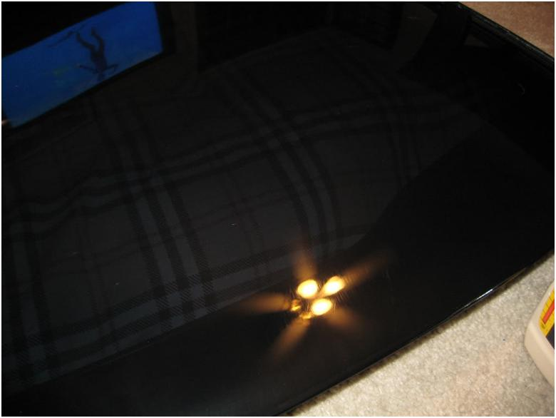
The medium cut cleaner does a good job of removing the sanding marks, but does leave the finish on the top hazy. I stepped up to a fine cut cleaner and polished out all of the haze.
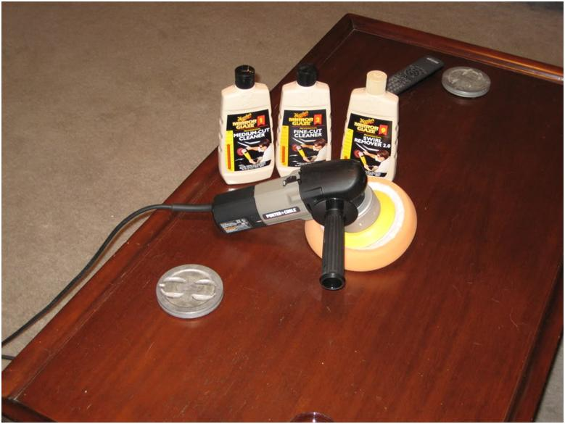
Then for good measure I stepped up to the swirl remove and got a great finish on the top.
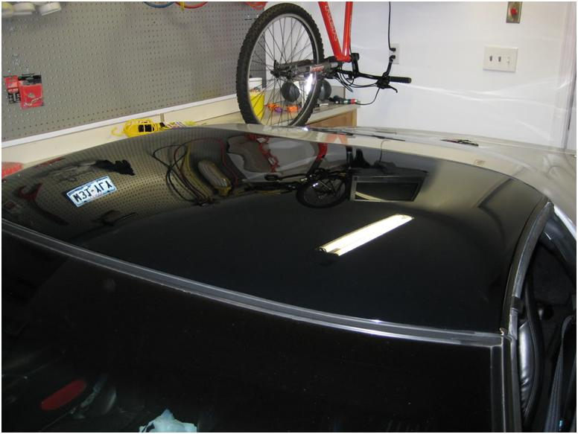
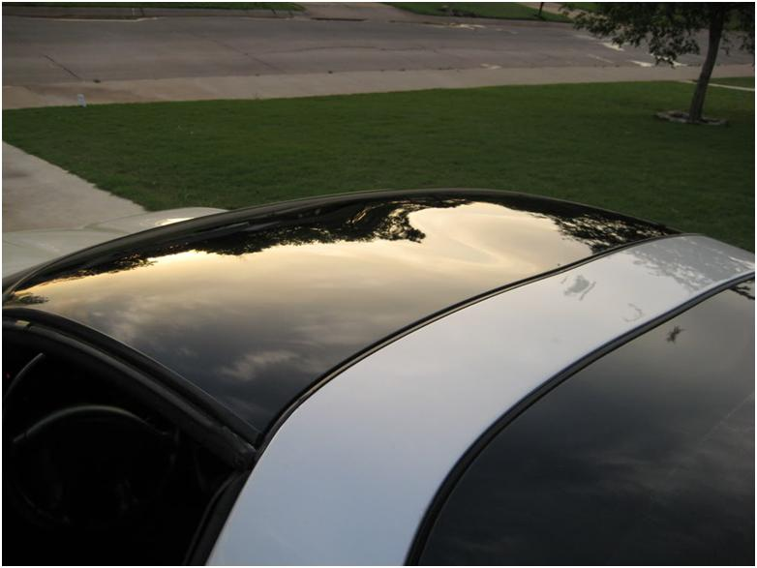
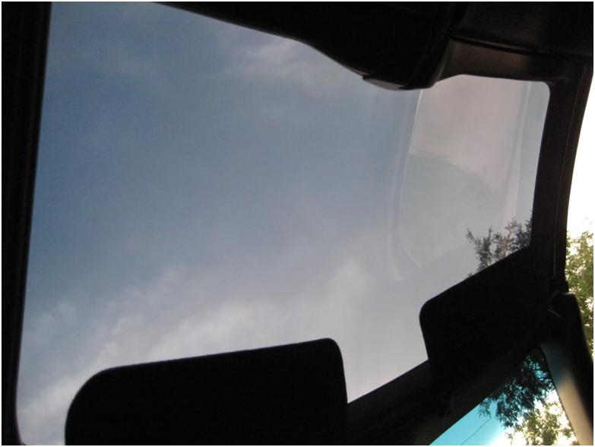
The other way to finish the top is to skip the clear coat step if you don't have access to paint gun or booth and just polish the acrylic. Step up from the 1000 grit finish to 1500, then 2000, alternating directions each time. Then polish as mentioned above.
You might also be able to find a local shop that can spray the clear for you for a good price. That way you won't have to mess with buying the clear and getting a booth and a charcoal mask to protect yourself from the fumes.
Hope this helps someone.

