Fuel Filter Replacement
All of these installations are to be performed at your own risk!!!!
FFS system (fuel pump with integrated fuel filter) initiated on November 25, 2002, with serial number 35111542. Ours is #35113294.

The last time I changed my fuel filter on my 02 ZO6 I was at a MOD Party that we organized. I started the filter change procedure and FORGOT to bring the damn tool to release the filter!!
Determined to do the filter swap, I used one of the plastic caps that comes on the new filter. I chopped of the top of the cap, then sliced the plastic sleeve in a spiral and used that plastic sleeve to disconnect the filter! Worked very well in a pinch!
http://forums.corvetteforum.com/attachments/c5-tech/47688010d1325816423-should-i-change-my-fuel-filter-ffs-tsb.jpg
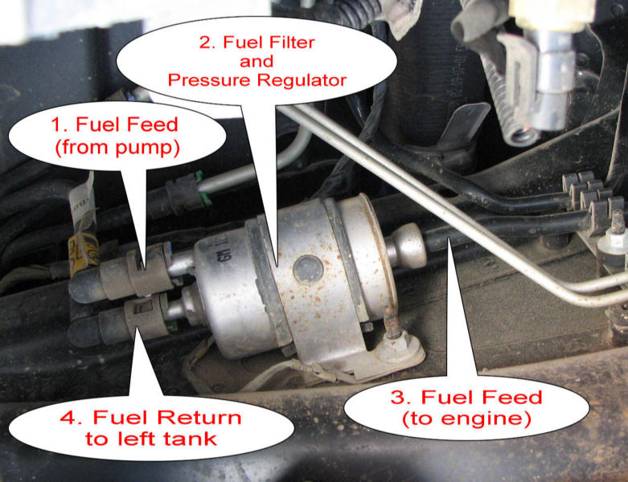

Disconnect your battery and suitably raise and support the rear of the vehicle enough that you can comfortably slide under there. The filter is located under the car on the driver side, on the side of the driveshaft (torquetube) tunnel, and the bracket is held on by one bolt. Release your gas cap, depress the Schraeder valve on the end of the driver’s side fuel rail to release pressure (use a rag to soak up fuel that comes out), then you're ready to disconnect the fuel lines.

- Clean the surrounding area around the filter before disconnecting to avoid contamination
- Disconnect the feed and return lines. You can use the proper tool (recommended) to do this or, like me, you can just carefully push in on the little tabs and it will come right off with no problems.
- Using a 10mm deep well, remove the bracket mount nut and also disconnect the feed from the outlet area.
- Cap the fuel lines if possible or just be careful not to contaminate.
- Disconnect the ground strap.
- Remove the filter from the car.
- Take off the retainers from the old filter and install them on the new filter.
Inside the inlet and outlet fuel line ends, there is a very small O ring. MAKE SURE that you look into the end of the fuel line and visibly inspect that O ring is in there. Make sure its still in there and in the O ring grove. If it isn't,,,,you will have a LEAK! Putting some lubricant on the ends of the fuel filter nipple will help get the filter seated without rolling the O rings.
- Connect the fuel feed pipe to the outlet.
- Install the new filter on the chassis and reconnect the ground. Tighten to 44 in. lbs.
- Connect the other two feeds.
- Turn ignition on for two seconds and then back off for 10 seconds.
- Turn ignition on and inspect for leaks.
