Inaccurate Gas Gauge Solution

Submitted by RJ1AJ (Vancouver, WA) on CorvetteForum.com. (5/16/08)

Like many of you, my 1998 had the dreaded "gauge drops to empty" problem. Mine would work off and on, so I'd just reset the trip odometer every time I filled up and lived with it.
Still, it really bugged me to not have the gauge working, so I did my homework on the forum, looking for a fix. I ran multiple bottles of Techron through it. Even tried Seafoam, and only filled up with Chevron Supreme. It improved a little, but still wouldn't work right.
When I reached my breaking point, I had our local performance guru hook it up to his scanner and troubleshoot it. I'd have to look up the procedure for diagnosing in the service manual, but long story short, the left side sending unit was registering 5 volts when it should've been less than 2.5 v.
So, started tracking down service bulletins and part numbers. The fuel sensor replacement kit for 97-2000 is #10333749 - $73 plus shipping from gmpartsdirect. I've got a buddy who can order parts and sold it to me at cost, so I knocked about $15 off that price and didn't have to pay shipping. NOTE: that part # includes the float, float arm, level sensor, and fuel strainer. I didn't know that at first, so now I've got an extra strainer laying around. Also, you have to buy a new gasket which comes with special bolts that have heads that shear off when they reach the correct torque (Part # 12458250). That was an extra $40.
The happy ending to the story is, that after about three hours of work, I no longer have to wonder "is the LOW FUEL warning real this time?"
"This thread is worthless without pictures" so here's a couple of the parts that came out.

This is the sending unit. Notice all the little comb teeth contacts - at the top they look like they're smeared together. I'm assuming those are the dreaded sulfur deposits that cause the havoc.
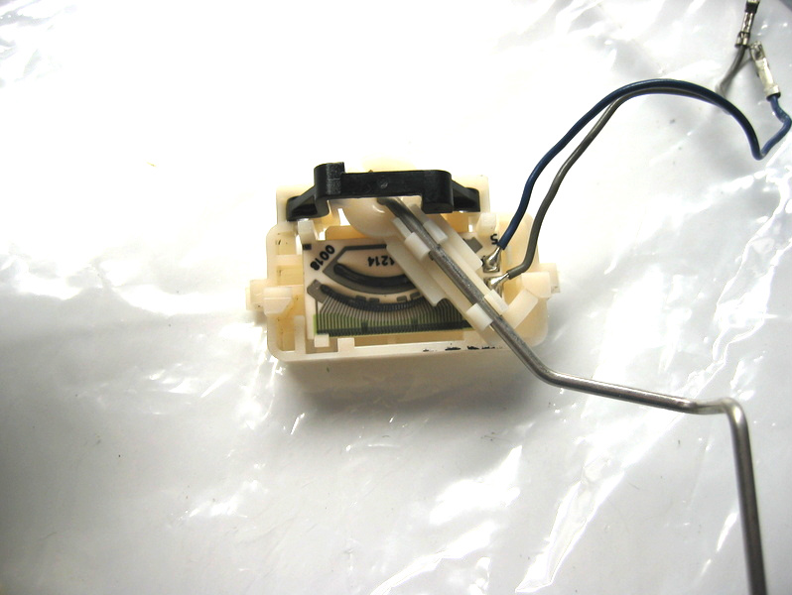
My fuel strainer looked like it had a pound of dirt trapped in it. Probably a good thing that I had to pull the sending unit, if only to get a clean strainer on there.
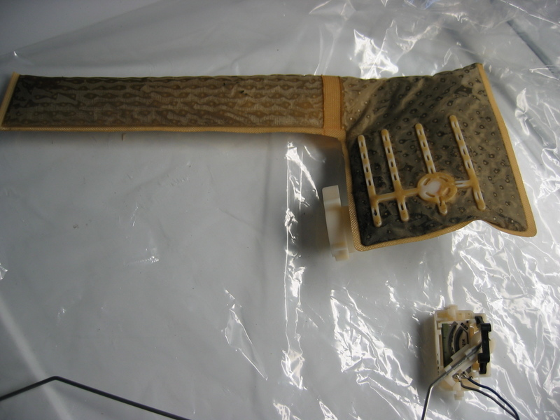
Anyway, if you've got the gas gauge problem, but are moderately mechanically inclined, get the parts and take care of it. It's a little tricky getting the float arm and fuel pump out of the tank and also putting it back again. But, it's well worth it when you can finally tell how much go-go juice you have in the tank!

